**S-100 – Part 17**

**Discovery Metadata for Information Exchange Catalogues**

Summary of Substantive Changes in Edition 5.2.0

|  |  |
| --- | --- |
| Change Summary | Clauses Effected |
| **Part 17 – Discovery Metadata for Information Exchange Catalogues** | |
| Added clarification regarding fileless dataset cancellation. | 17-4.4.1 |
| Updated Figure 17-7 to change S100_SE_DigitalSignatureReference enumeration value to ECDSA-384-SHA2 (value 8). | 17-4.4.1 |
| Added clarification that the S-100 Exchange Catalogue profile cannot be extended at the Product Specification level. | 17-4.5 |
| Added new note for Class table S100_DataCoverage specifying the method by which the boundingPolygon is to be represented in GML encoding. | 17-4.5 |

**Contents**

17-1 Scope 1

17-2 Conformance 1

17-2.1 Conformance of this Profile with other Standards 1

17-2.2 Conformance to this Profile 1

17-3 Normative references 1

17-3.1 Profile definition 1

17-3.2 Informative references 2

17-4 Overview 2

17-4.1 S-100 Exchange Set Structure 2

17-4.2 S-100 Exchange Set Folder Structure. 5

17-4.3 Storage and Management of External Resources 7

17-4.3.1 Supported resources / multiple references guidance 8

17-4.3.2 ISOMetadataFile guidance 8

17-4.4 S-100 Exchange Set Catalogue 9

17-4.4.1 New Editions, revisions, updates and cancellations 9

17-4.5 Elements of the Exchange Set Catalogue 12

17-4.6 Overview of multilingual support in S-100 Exchange Set Catalogue 29

17-4.7 Encoding of S-100 Exchange Set Catalogue elements in multiple languages 30

17-4.8 Indicating languages used inside geospatial resources described in S-100 Exchange Set Catalogue 31

17-4.9 Encoding of maintenance information 32

17-4.9.1 Encoding and interpretation rules in S-100 metadata 33

Page intentionally left blank

# Scope

The S-100 Discovery Metadata for Information Exchange Catalogues profile described in this Part provides a specification for describing and creating Exchange Catalogues that enables users to identify, discover and manage content of the S-100 Exchange Sets. More importantly it leverages XML to allow machine to machine discovery and exchange of information about geographic datasets commonly produced by hydrographic organizations. Its purpose is the creation of metadata records that provide information about the identification, spatial and temporal extent, quality, Application Schema, spatial reference system, and distribution of digital geographic data. It is applicable to the cataloguing of datasets, clearinghouse activities, and the full description of geographic and non-geographic resources.

For information exchange, there are several categories of metadata required: metadata about the overall Exchange Catalogue, metadata about each of the datasets contained in the Catalogue, and metadata about the support files that make up the package. If the Exchange Catalogue contains any Feature, Portrayal or Interoperability Catalogues there is a provision to carry additional metadata about those.

This document is intended for developers and implementers of metadata applications, and provides a basic understanding of the principles and the overall requirements for standardisation of geographic information. It should be used in conjunction with the standards listed under clause 4a-4 – Normative references.

# Conformance

## Conformance of this Profile with other Standards

The S-100 Discovery Metadata for Information Exchange Catalogues profile adopts data types defined in other ISO standards, mainly in ISO 19115-1 Geographic information – Metadata – Part 1 - Fundamentals, ISO/TS 19115-3:2016, Geographic information - Metadata - XML Schema implementation for fundamental concepts and ISO 19136 Geographic Information - Geography Markup Language, along with their underlying obligations and conditions. The XML Schema references related to these external data types are embedded in the XML Schemas for this profile, thus ensuring the conformance of this profile with other standards during authoring and validation of XML catalogue instances.

## Conformance to this Profile

The conformance to this profile can be confirmed by validating XML catalogue instances against the S-100 Metadata Profile Schemas which are available from the IHO S-100 repository.

# Normative references

The following referenced documents are required for the application of this document. For dated references, only the edition cited applies. For undated references, the latest edition of the referenced document (including amendments) applies.

## Profile definition

The following documents were the references used to define the S-100 Metadata Profile:

ISO 19115-1:2014, *Geographic information – Metadata – Part 1 - Fundamentals*

ISO 19115-1/Amdt01:2018, *Geographic information – Metadata – Part 1 - Fundamentals* (Amendment 1)

ISO 19115-2:2009, *Geographic information - Metadata - Part 2: Extensions for imagery and gridded data*

ISO 19119:2016, *Geographic information – Services*

ISO/TS 19115-3:2016, *Geographic information - Metadata - XML schema implementation for fundamental concepts*

## Informative references

ISO 19115:2003, *Geographic information – Metadata*

ISO 19115:2003/Cor.1:2006, *Geographic information - Metadata* (Technical Corrigendum 1)

ISO/TS 19139:2007, *Geographic information - Metadata - XML schema implementation*

# Overview

## S-100 Exchange Set Structure

The S-100 Exchange Set is a data container that provides all the elements needed for a reliable and secure exchange of S-100 conformant data. It is intended to be a self-contained entity consisting of data files and metadata records packaged together using applicable data integrity and optional security provisions. The overall concept of the S-100 Exchange Set is a realization of the ISO 19115-3 classes, which fundamentally underpin the interchange of geospatial data and relevant metadata, as depicted in Figure 17-1 below. This Figure depicts, from left to right, the ISO data exchange structural classes, the relevant ISO classes for metadata for exchange, S-100 structure classes representing the S-100 Exchange Set components, and the relevant S-100 Exchange Set metadata classes.

Note that the S-100 structure classes represent components of the Exchange Set (files/folders/archives), not XML fragments in an exchange file. Accordingly, they do not have attributes nor do they have corresponding documentation tables in this Part.

Note also that the S-100 Exchange Set metadata classes are analogues of the corresponding ISO classes but (strictly speaking) not specialisations or realisations of them.

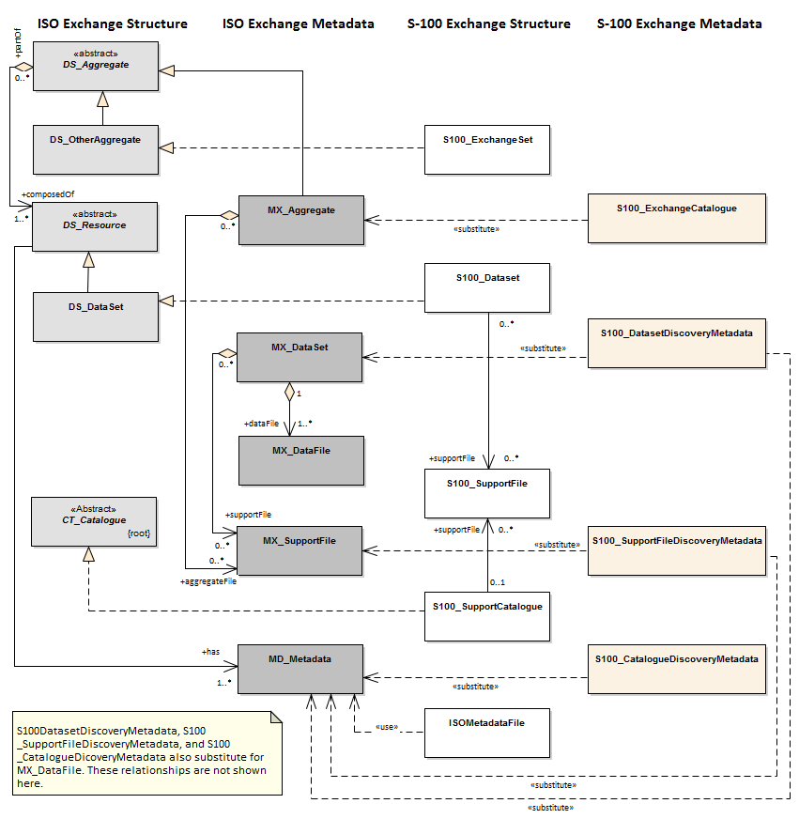

Figure 17-1 Realization of the Exchange Set classes

The above Figure illustrates the conceptual correspondence between data exchange provisions in ISO-19115-3 and S-100 standards. At an implementation level, the S-100 Exchange Set may include a combination of S-100 datasets, support files, and Catalogue files along with the metadata information for all such resources in the form of the S-100 Exchange Set Catalogue. Conceptually this leads to the more detailed model of the S-100 Exchange Set, as shown in Figure 17-2 below.

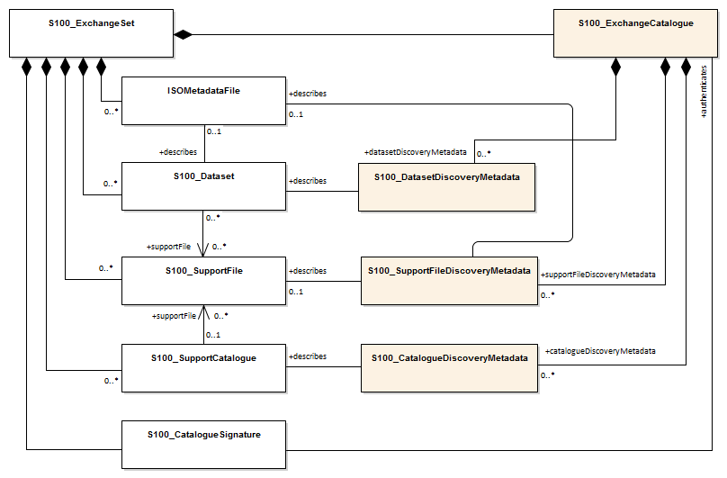

Figure 17-2 – S-100 Exchange Set

The conceptual model depicted in Figure 17-2 is very flexible and can be implemented in a variety of ways as virtually all components, except for the S-100_ExchangeCatalogue, are optional. This level of flexibility is essential to properly support the mainstream use case of exchanging geospatial data, as well as the use cases for releasing dataset and support file cancellation notices or new Catalogue releases without any data files present.

This approach ensures that an Exchange Set Catalogue is always included in any S-100 conformant Exchange Set, providing the essential discovery metadata about any included resources and their intended use.

Preparation of an Exchange Set consists of packaging its components using a predefined file folder structure shown in Figure 17-3 below.

## S-100 Exchange Set Folder Structure.

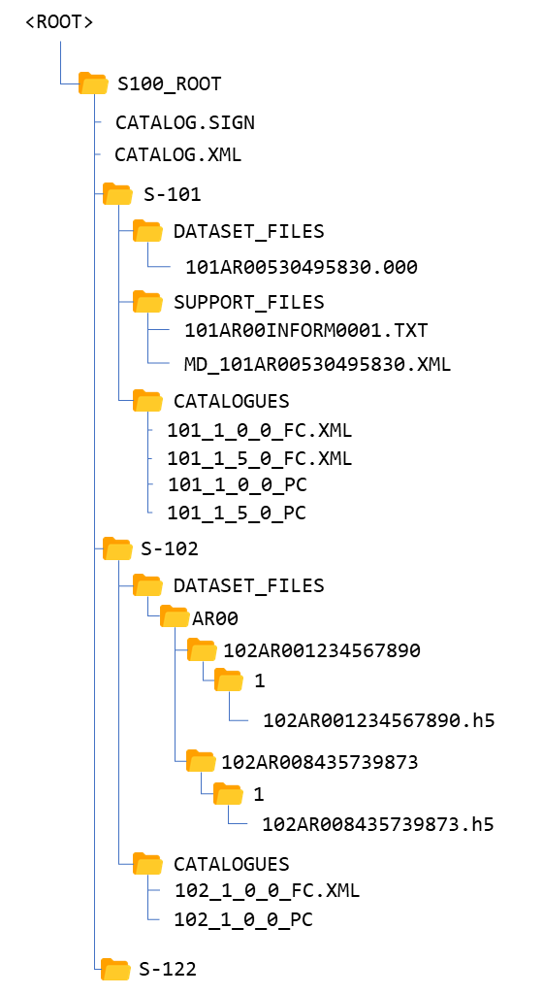

Figure 17-3 – An S-100 Exchange Set folder structure

1. An S-100 Exchange Set must contain an Exchange Set Catalogue, CATALOG.XML, its digital signature CATALOG.SIGN and may contain any number of S-100 conformant dataset files, support files and Catalogue files.
2. All S-100 content must be placed inside a top root folder named S100_ROOT. This is the only top level root folder in an Exchange Set containing only S-100 products.
3. The S100_ROOT folder must contain a subfolder for each specific S-100 Product Specification data type included in the Exchange Set; for example S-101, S-104, S-102 (names defined in the Product Specification Register of the IHO Geospatial Information (GI) Registry). These subfolders hold S-100 content specific to an individual Product Specification.
4. Each product subfolder must contain subfolders for the component dataset files (DATASET_FILES), support files (SUPPORT_FILES) and Catalogues (CATALOGUES) as required.
5. Individual data files may be optionally placed in their own subfolders (as demonstrated in the S-102 folder in Figure 17-3 above) or grouped together (as demonstrated in the S-101 folder in Figure 17-3 above). The ISOMetadataFile (see Figure 17-2) must be located in the SUPPORT_FILES folder. If used, all associated ISOMetadataFile must follow the MD_<data file base name>.XML file naming convention.
6. Support files, on the other hand, may be grouped together in one folder to prevent duplication across multiple dataset folders. Similarly, when needed, an Exchange Set may carry additional Catalogues and/or their different versions which should also be grouped together in one folder.
7. The required Exchange Set Catalogue XML document instance must be named CATALOG.XML and placed in the S100_ROOT folder, together with its digital signature (CATALOG.SIGN) file. All other digital signatures are included within their corresponding resource metadata records in the CATALOG.XML.

An S-100 Exchange Set can be optionally defined alongside S-57 datasets with their own ENC_ROOT and INFO root folders as required by the S-57 ENC Product Specification and (optionally) S-63. In this case there are three top level folders: ENC_ROOT and INFO for S-57, and S100_ROOT with two separate Catalogues covering their respective content (CATALOG.031 and CATALOG.XML). Figure 17-4 below shows one of these use cases with S-57 and multiple S-100 products included.

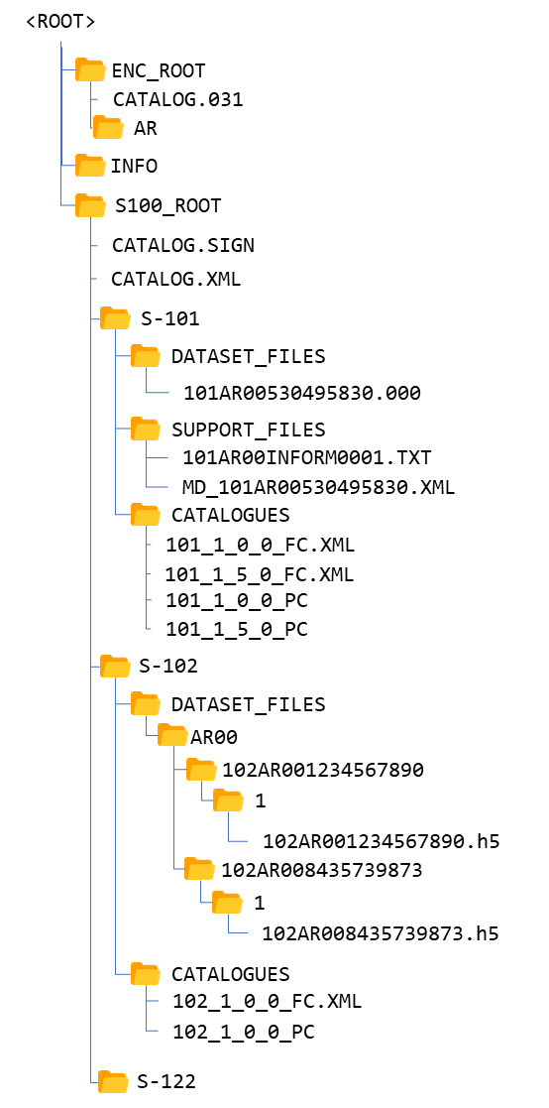

Figure 17-4 – Combined S-100 and S-57 Exchange Sets folder structure

In addition to the folder structure, it is important to align the Exchange Set creation workflow with the data integrity and security provisions outlined in S-100 Part 15. These provisions cover digital signing, compression, and encryption of Exchange Set resources. All resources within an S-100 Exchange Set must be digitally signed and their signatures included in the Exchange Set Catalogue. Data compression and encryption are optional operations.

Exchange Set creation, therefore, consists of:

1. The creation of a suitable Exchange Set folder structure.
2. The arrangement of all resources in their designated folders.
3. Optional compression and encryption of any resources which require it.
4. Creation of digital signatures for all resources.
5. Construction of an Exchange Set Catalogue which records the structure created.

S-100 Part 15 defines the requirements and process for creation and verification of digital signature values and production of compressed/encrypted datasets.

## Storage and Management of External Resources

S-100 datasets may refer to a number of externally referenced, supporting resources for content. This content may be textual or graphical and encoded in any of a number of formats (defined by the S100_SupportFileFormat enumeration in the Exchange Catalogue Schema). Datasets hold a reference to the external resource as an attribute value. This value may be updated as any other attribute and updates the reference to the external resource. External resources can support either datasets or Catalogues or can be standalone entities in the Exchange Set

The S-100 Exchange Catalogue provides:

1. A normative definition of the location of each supporting resource. Where these are physical files this is a physical location within the <*S-100 Product*>/SUPPORT_FILES subdirectory in the Exchange Catalogue file structure.
2. For each unique reference to an external resource encoded in a dataset or a supporting resource required by a Catalogue, the Exchange Catalogue provides a unique map (by reference) in the metadata entry for the resource to the dataset or Catalogue metadata entry for which it is required.

For example:

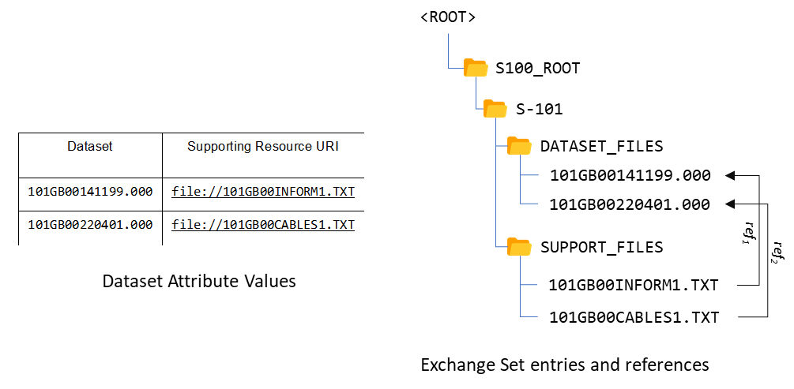

Figure 17-5 – Exchange Set supporting resources (example)

All content relating to such external resources should be validated and must be consistent with the dataset content to form a valid S-100 Exchange Set.

Datasets refer to external resources using S-100 attributes with a URI primitive type. Such references must use S-100 URI form and must be uniquely resolvable by the implementing system without requiring any supplementary information within the Exchange Catalogue metadata entries.

Examples of such URI definitions are:

Table 17-1 – URI references (examples)

|  |  |
| --- | --- |
| **URI type** | **Example URI** |
| File reference | file::101GB00400797.TXT |
| MRN (S-100 Digital Signature Value) | urn:mrn:iho:s100:dsig:dsa:MEQCIDDzwjK4ksBsMx-AADc5eGQ9uI9Qi8oDx0lVdavMshZnAiBKx_m4KPS3Kk8zYJx-nzeJzhs_H_VHWpVkdtExAqJ-0Q== |

Full specification of file URIs and MRNs supported by S-100 are contained in S-100 Part 1, clause 1-4.6. Use of different types of URIs by ECDIS implementations may be restricted in ECDIS implementations by S-98 Annex C.

As long as the mapping from the external resource metadata to the dataset metadata is unique it is valid, so multiple datasets are able to “share” common external resources within an Exchange Catalogue without ambiguity. To provide unambiguous file URIs from external resources to datasets all base dataset filenames must be unique

Dataset naming shall follow a standard pattern to give implementers the assurance of unique base dataset filenames for incoming datasets.

XXXYYYYØØØØØØØØØ.[EXT]

* XXX is the product code (for example, 123 is for Maritime Radio Services; 101 for ENC)
* YYYY is the producer code according to the Producer Code Register
* ØØØØ is an arbitrary length unique code in alphanumeric characters including any differentiating characters as required. The code shall be unique for the data producer (that is, different data producers may use the same code) and not re-used.
* [EXT] is the file encoding specific file extension

Supporting resources shall follow the same naming convention, except for the ISOMetadataFile which must use the structure MD_<data file base name>.XML. To further assist implementers, data producers shall ensure that the content in the latest revision of supporting resources is specific to the unqiue code used. Differing content in supporting resources shall be assigned different unique codes across an individual Data Producer’s entire content.

A supporting resource cannot be shared across Product Specifications.

Use of the file name in a file URI allows an exchange set producer to maintain a single, up-to-date version of any supporting file resource without necessitating dataset updates when the content of the resource changes. If a data producer wishes to ensure a dataset update is produced whenever supporting resource content changes then use of either digital signature or checksum URIs in the dataset shall be used .

### Supported resources / multiple references guidance

One single support file can be referenced by feature attributes in multiple datasets. This creates some complexity in a scenario where the support file content is updated, and the changes do not apply to all the datasets currently referencing the support file.

If applicable, in the situation where one support file is referenced by multiple datasets and the support file content changes and initiates a new edition of the support file, all the datasets referencing the support file will adhere to the new edition. If the support file change is not applicable to all datasets referencing it, a new support file must be created for the new changes, and the dataset references to the old support file must be deleted and references to the new support file added. For the datasets not applicable to the change, the old support file and reference will still be valid.

For further detailed explanation refer to S-98.

### ISOMetadataFile guidance

The S-100 Exchange Set model provides a mechanism for including ISO compliant metadata records for each dataset in an Exchange Set. These optional supporting resources can be included and referenced using the individual ISOMetadataFile records. They are not intended to be used on ECDIS, but may be optionally included to support wider interoperability with other user communities or to fulfil ISO metadata requirements where needed.

## S-100 Exchange Set Catalogue

The S100 Exchange Set Catalogue is an XML document instance, which provides the metadata information needed to discover and use the resources contained in the S-100 Exchange Set. It must be named CATALOG.XML. This mandatory, central component of S-100 Exchange Sets consists of several components which capture suitable metadata records for each resource type. These components cover metadata for the Exchange Set Catalogue, dataset discovery, support file discovery, any references to ISO 19115-1/2/3 dataset metadata, and additional Catalogues as depicted in Figure 17-4 above.

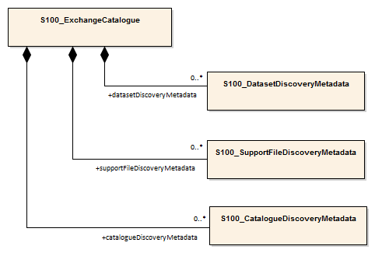

Figure 17-6 – S-100 Exchange Set Catalogue

The discovery metadata subsections have attributes which enable important information about the datasets and accompanying support files to be examined without the need to process the data, for example encryption/compression flags. Similarly, other Catalogues can be included in the S-100 Exchange Set, in support of the datasets, such as feature, portrayal, coordinate reference systems, codelists etc. In addition, the S100 Exchange Set Catalogue provides mechanisms for managing the lifecycle of records, support resources and catalogues. For example, the S100_SupportFileRevisionStatus and S100_Purpose enumerations support a revision control mechanism not only for delivering new versions and revisions, but also for cancelling such resources. This provides the ability to cancel records, support resources and catalogues using the S100 Exchange Set Catalogue records, rather than publishing incremental versions of the actual resources.

More detailed information about the various elements of the Catalogue is shown in Figure 17-7 below and in the textual description in the Tables at clause 17-4.5.

### New Editions, revisions, updates and cancellations

This section defines the sequencing of datasets for New Editions and, where a particular S-100 encoding supports incremental updates, updates and re-issues. In order to ensure that feature type updates are incorporated into an end user system in the correct sequence without any omission, a number of parameters encoded in the data and metadata are used in the following way:

**Edition number** When a dataset is initially created (Base dataset), the Edition number 1 is assigned to it. The Edition number is increased by 1 at each New Edition.

**Update number** Update number 0 is assigned to a new dataset and a New Edition. The first update dataset file associated with this new dataset must have update number 1. The update number must be increased by one for each subsequent update, until a New Edition is released.

A re-issue of a dataset must have the update number of the last update applied to the dataset, and use the same Edition number.

**Issue date** Date up to which the Data Producer has incorporated all applicable changes. The issue date must be greater than the previous issue date of the dataset.

In addition to fileless dataset cancellation using fields in the Catalogue metadata file (S100_Purpose = cancelled) a dataset may be cancelled by the Data Producer by the issuing of a cancellation update. In order to cancel a dataset, an update dataset file is created for which the Edition number must be set to 0. This method is only used to cancel a Base dataset file. Where a dataset is cancelled and its name is reused at a later date, the issue date must be greater than the issue date of the cancelled dataset. When the dataset is cancelled it must be removed from the system. Fileless cancellation may be achieved by using a dataset metadata entry with the filename and original digital signature specifying the resource to be cancelled, and with all other mandatory metadata fields also set to the same values as the original, with the exception of the issueDate, which must be set to the issue date of the fileless cancellation itself.

An Exchange Set may contain Base dataset files and update dataset files for the same datasets. Under these circumstances the update dataset files must follow on in the correct sequential order from the last update applied to the Base dataset file.

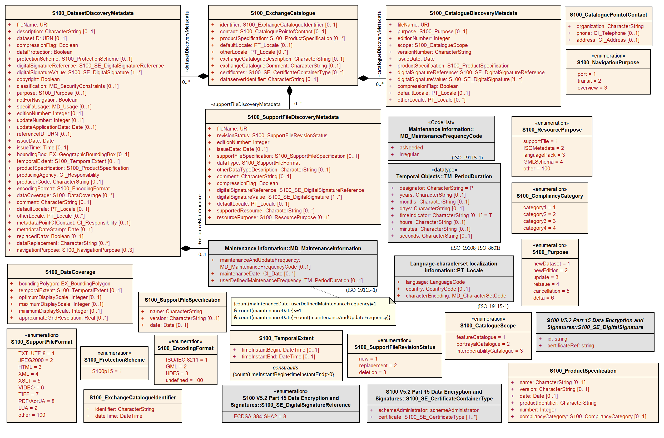

Figure 17-7 – S-100 Exchange Set Catalogue – class details

## Elements of the Exchange Set Catalogue

The tables in this section provide a detailed textual description of the encoding of the S-100 Exchange Set Catalogue. The design follows a number of key design principles that have been consistently applied throughout the development process.

One of these principles drives the choice of multiplicity value assignments. At the S-100 framework level, the majority of S-100 Exchange Set Catalogue elements are intended to be optional and therefore have their lower multiplicity bound set to 0. Only those elements that are considered absolutely necessary across all S-100 data products have their lower multiplicity bound set to 1, effectively making them mandatory for all data products. Overall, the resulting multiplicity values at the S-100 Framework level are considered to be a starting point for S-100 Product Specification developers and can be overridden at the individual data product level if necessary.

Another principle was to retain some of the existing element names for historical reasons. For example, the naming of the NotForNavigation element could be improved, but this element was retained from previous versions for backwards compatibility reasons. Similarly, the terms file and resource are used interchangeably in the model and for historical reasons.

For Product Specifications to be used in S-100 ECDIS, covered by S-98, a third principle is that the S-100 Exchange Catalogue profile cannot be extended at the Product Specification level. This principle exists so that implementers of the S-100 Exchange Catalogue profile are not required to consider product specific extensions.

S100_ExchangeCatalogue

Each Exchange Set has a single S100_ExchangeCatalogue which contains meta information for the data and support files in the Exchange Set.

|  |  |  |  |  |  |
| --- | --- | --- | --- | --- | --- |
| **Role Name** | **Name** | **Description** | **Mult** | **Type** | **Remarks** |
| Class | S100_ExchangeCatalogue | An Exchange Catalogue contains the discovery metadata about the exchange datasets and support files | - | - | - |
| Attribute | identifier | Uniquely identifies this Exchange Catalogue | 0..1 | S100_ExchangeCatalogueIdentifier |  |
| Attribute | contact | Details about the issuer of this Exchange Catalogue | 0..1 | S100_CataloguePointOfContact |  |
| Attribute | productSpecification | Details about the Product Specifications used for the datasets contained in the Exchange Catalogue | 0..* | S100_ProductSpecification |  |
| Attribute | defaultLocale | Default language and character set used for all metadata records in this Exchange Catalogue | 0..1 | PT_Locale | Default is English and UTF-8 |
| Attribute | otherLocale | Other languages and character sets used for the localized metadata records in this Exchange Catalogue | 0..* | PT_Locale | Required if any localized entries are present in the Exchange Catalogue |
| Attribute | exchangeCatalogueDescription | Description of what the Exchange Catalogue contains | 0..1 | CharacterString |  |
| Attribute | exchangeCatalogueComment | Any additional Information | 0..1 | CharacterString |  |
| Attribute | certificates | Signed public key certificates referred to by digital signatures in the Exchange Set | 0..* | S100_SE_CertificateContainerType | Content defined in S-100 Part 15. All certificates used, except the SA root certificate (installed separately by the implementing system) shall be included |
| Attribute | dataServerIdentifier | Identifies the data server for the permit | 0..1 | CharacterString |  |
| Role | datasetDiscoveryMetadata | Exchange Catalogues may include or reference discovery metadata for the datasets in the Exchange Set | 0..* | Aggregation S100_DatasetDiscoveryMetadata |  |
| Role | catalogueDiscoveryMetadata | Metadata for Catalogue | 0..* | Aggregation S100_CatalogueDiscoveryMetadata | Metadata for the Feature, Portrayal and Interoperability Catalogues, if any |
| Role | supportFileDiscoveryMetadata | Exchange Catalogues may include or reference discovery metadata for the support files in the Exchange Set | 0..* | Aggregation S100_SupportFileDiscoveryMetadata |  |

S100_ExchangeCatalogueIdentifier

| **Role Name** | **Name** | **Description** | **Mult** | **Type** | **Remarks** |
| --- | --- | --- | --- | --- | --- |
| Class | S100_ExchangeCatalogueIdentifier | An identifier for an Exchange Catalogue . | - | - | The concatenation of identifier and dateTime form the unique name |
| Attribute | identifier | Uniquely identifies this Exchange Catalogue | 1 | CharacterString | <S100XC:identifier>US_101_20200101_120101_01</S100XC:identifier> |
| Attribute | dateTime | Creation date and time of the Exchange Catalogue, including time zone | 1 | DateTime | Format: yyyy-mm-ddThh:mm:ssZ |

S100_CataloguePointofContact

|  |  |  |  |  |  |
| --- | --- | --- | --- | --- | --- |
| **Role Name** | **Name** | **Description** | **Mult** | **Type** | **Remarks** |
| Class | S100_CataloguePointOfContact | Contact details of the issuer of this Exchange Catalogue | - | - | - |
| Attribute | organization | The organization distributing this Exchange Catalogue | 1 | CharacterString | This could be an individual producer, value added reseller, etc |
| Attribute | phone | The phone number of the organization | 0..1 | CI_Telephone |  |
| Attribute | address | The address of the organization | 0..1 | CI_Address |  |

S100_DatasetDiscoveryMetadata

| **Role Name** | **Name** | **Description** | **Mult** | **Type** | **Remarks** |
| --- | --- | --- | --- | --- | --- |
| Class | S100_DatasetDiscoveryMetadata | Metadata about the individual datasets in the Exchange Catalogue | - | - | - |
| Attribute | fileName | Dataset file name | 1 | URI | See Part 1, clause 1-4.6 |
| Attribute | description | Short description giving the area or location covered by the dataset | 0..1 | CharacterString | For example, a harbour or port name, between two named locations etc |
| Attribute | datasetID | Dataset ID expressed as a Maritime Resource Name | 0..1 | URN | The URN must be an MRN |
| Attribute | compressionFlag | Indicates if the resource is compressed | 1 | Boolean | *True* indicates a compressed dataset resource  *False* indicates an uncompressed dataset resource |
| Attribute | dataProtection | Indicates if the data is encrypted | 1 | Boolean | *True* indicates an encrypted dataset resource  *False* indicates an unencrypted dataset resource |
| Attribute | protectionScheme | Specification of method used for data protection | 0..1 | S100_ProtectionScheme |  |
| Attribute | digitalSignatureReference | Specifies the algorithm used to compute digitalSignatureValue | 1 | S100_SE_DigitalSignatureReference  (see Part 15) |  |
| Attribute | digitalSignatureValue | Value derived from the digital signature | 1..* | S100_SE_DigitalSignature  (see Part 15) | The value resulting from application of digitalSignatureReference  Implemented as the digital signature format specified in Part 15 |
| Attribute | copyright | Indicates if the dataset is copyrighted | 1 | Boolean | *True* indicates the resource is copyrighted  *False* Indicates the resource is not copyrighted |
| Attribute | classification | Indicates the security classification of the dataset | 0..1 | Class MD_SecurityConstraints>MD_ClassificationCode (codelist) | 1. unclassified  2. restricted  3. confidential  4. secret  5. top secret  6. sensitive but unclassified  7. for official use only  8. protected  9. limited distribution |
| Attribute | purpose | The purpose for which the dataset has been issued | 0..1 | S100_Purpose |  |
| Attribute | notForNavigation | Indicates the dataset is not intended to be used for navigation | 1 | Boolean | *True* indicates the dataset is not intended to be used for navigation  *False* indicates the dataset is intended to be used for navigation |
| Attribute | specificUsage | The use for which the dataset is intended | 0..1 | MD_USAGE>specificUsage (character string) |  |
| Attribute | editionNumber | The Edition number of the dataset | 0..1 | Integer | When a data set is initially created, the Edition number 1 is assigned to it. The Edition number is increased by 1 at each new Edition. Edition number remains the same for a re-issue |
| Attribute | updateNumber | Update number assigned to the dataset and increased by one for each subsequent update | 0..1 | Integer | Update number 0 is assigned to a new dataset |
| Attribute | updateApplicationDate | This date is only used for the base cell files (that is new data set, re-issue and new edition), not update cell files. All updates dated on or before this date must have been applied by the producer | 0..1 | Date |  |
| Attribute | referenceID | Reference back to the datasetID | 0..1 | URN | Update metadata refers to the datasetID of the dataset metadata. This is used if and only if the dataset is an update  The URN must be an MRN |
| Attribute | issueDate | Date on which the data was made available by the Data Producer | 1 | Date |  |
| Attribute | issueTime | Time of day at which the data was made available by the Data Producer | 0..1 | Time | The S-100 datatype Time |
| Attribute | boundingBox | The extent of the dataset limits | 0..1 | EX_GeographicBoundingBox | - |
| Attribute | temporalExtent | Specification of the temporal extent of the dataset | 0..1 | S100_TemporalExtent | The temporal extent is encoded as the date/time of the earliest and latest data records (in coverage datasets) or date/time ranges (in vector datasets)  If there is more than one feature in a dataset, the earliest and latest time values of records in all features are used, which means the earliest and latest values may be from different features  If date/time information for a feature is not encoded in the dataset, it is treated for the purposes of this attribute as extending indefinitely in the appropriate direction on the time axis, limited by the issue date/time or the cancellation or supersession of the dataset  This attribute is encoded if and only if at least one of the start and end of the temporal extent is known |
| Attribute | productSpecification | The Product Specification used to create this dataset | 1 | S100_ProductSpecification |  |
| Attribute | producingAgency | Agency responsible for producing the data | 1 | CI_Responsibility>CI_Organisation | See Table 17-3 |
| Attribute | producerCode | The official IHO Producer Code from S-62 | 0..1 | CharacterString |  |
| Attribute | encodingFormat | The encoding format of the dataset | 1 | S100_EncodingFormat |  |
| Attribute | dataCoverage | Provides information about data coverages within the dataset | 0..* | S100_DataCoverage |  |
| Attribute | comment | Any additional information | 0..1 | CharacterString |  |
| Attribute | defaultLocale | Default language and character set used in the dataset | 0..1 | PT_Locale | In absence of defaultLocale the language is English, UTF-8 |
| Attribute | otherLocale | Other languages and character sets used in the dataset | 0..* | PT_Locale |  |
| Attribute | metadataPointOfContact | Point of contact for metadata | 0..1 | CI_Responsibility>CI_Individual or  CI_Responsibility>CI_Organisation | Only if metadataPointOfContact is different to producingAgency |
| Attribute | metadataDateStamp | Date stamp for metadata | 0..1 | Date | May or may not be the issue date |
| Attribute | replacedData | Indicates if a cancelled dataset is replaced by another data file(s) | 0..1 | Boolean | See Note |
| Attribute | dataReplacement | Dataset name | 0..* | CharacterString | A dataset may be replaced by 1 or more datasets  See Note |
| Attribute | navigationPurpose | Classification of intended navigation purpose (for Catalogue indexing purposes) | 0..3 | S100_NavigationPurpose | If Product Specification is intended for creation of navigational products this attribute should be mandatory |
| Role | resourceMaintenance | Information about the frequency of resource updates, and the scope of those updates | 0..1 | MD_MaintenanceInformation | S-100 restricts the multiplicity to 0..1 and adds specific restrictions on the ISO 19115 structure and content. See clause MD_MaintenanceInformation later in this Part  Format: PnYnMnDTnHnMnS (XML built-in type for ISO 8601 *duration*). See clause 17-4.9 |

NOTE: replacedData and dataReplacement: The intended use of the attributes replacedData and dataReplacement could be, for example, to provide a mechanism for service providers to build automation when providing replacement data sets to customers within existing subscription periods.

**S100_NavigationPurpose**

|  |  |  |  |  |
| --- | --- | --- | --- | --- |
| **Item** | **Name** | **Description** | **Code** | **Remarks** |
| Enumeration | S100_NavigationPurpose | The navigational purpose of the dataset | - |  |
| Value | port | For port and near shore operations | 1 | - |
| Value | transit | For coast and planning purposes | 2 | - |
| Value | overview | For ocean crossing and planning purposes | 3 | - |

S100_DataCoverage

|  |  |  |  |  |  |
| --- | --- | --- | --- | --- | --- |
| **Role Name** | **Name** | **Description** | **Mult** | **Type** | **Remarks** |
| Class | S100_DataCoverage | A spatial extent where data is provided; and the display scale information for the provided data | - | - | This field is used by user systems as part of the data loading and unloading algorithms and it is strongly encouraged that Product Specifications mandate the use of one or more of the displayScale provided as part of S100_DataCoverage |
| Attribute | boundingPolygon | A polygon which defines the actual data limit | 1..1 | EX_BoundingPolygon | (See Note 1) |
| Attribute | temporalExtent | Specification of the temporal extent of the coverage | 0..1 | S100_TemporalExtent | The remarks for *temporalExtent* in the dataset discovery block (S100_DatasetDiscoveryMetadata) apply, except that their scope is the individual coverage and not the dataset as a whole |
| Attribute | optimumDisplayScale | The scale with which the data is optimally displayed | 0..1 | Integer | Example: A scale of 1:25000 is encoded as 25000 |
| Attribute | maximumDisplayScale | The maximum scale with which the data is displayed | 0..1 | Integer |  |
| Attribute | minimumDisplayScale | The minimum scale with which the data is displayed | 0..1 | Integer |  |
| Attribute | approximateGridResolution | The resolution of gridded or georeferenced data (in metres) | 0..* | Real | A single value may be provided when all axes have a common resolution  For multiple value provision, use axis order as specified in dataset  May be approximate for ungeorectified data  For example, for 5 metre resolution, the value 5 must be encoded  (See Note 2) |

NOTE 1: boundingPolygon is restricted to a single GML Polygon with one exterior and 0 or more interiors expressed as Linear Rings using SRS EPSG:4326. The exterior and optional interiors shall be composed of a closed sequence of >=4 coordinate positions expressed individually or as a list (posList). The GML polygon shall have a valid GML identifier.

NOTE 2: approximateGridResolution: If the grid cell size varies over the extent of the grid, an approximated value based on model parameters or production metadata should be used.

S100_Purpose

|  |  |  |  |  |
| --- | --- | --- | --- | --- |
| **Item** | **Name** | **Description** | **Code** | **Remarks** |
| Enumeration | S100_Purpose | The purpose of the dataset | - |  |
| Value | newDataset | Brand new dataset | 1 | No data has previously been produced for this area |
| Value | newEdition | New edition of the dataset or Catalogue | 2 | Includes new information which has not been previously distributed by updates |
| Value | update | Dataset update | 3 | Changing some information in an existing dataset |
| Value | reissue | Dataset that has been re-issued | 4 | Includes all the updates applied to the original dataset up to the date of the re-issue. A re-issue does not contain any new information additional to that previously issued by updates. |
| Value | cancellation | Dataset or Catalogue that has been cancelled | 5 | Indicates the dataset or Catalogue should no longer be used and can be deleted |
| Value | delta | Dataset difference | 6 | Reserved for future use |

S100_TemporalExtent

|  |  |  |  |  |  |
| --- | --- | --- | --- | --- | --- |
| **Role Name** | **Name** | **Description** | **Mult** | **Type** | **Remarks** |
| Class | S100_TemporalExtent | Temporal extent | -- |  | At least one of the timeInstantBegin and timeInstantEnd attributes must be populated; if both are known, both must be populated. The absence of either begin or end indicates indefinite validity in the corresponding direction, limited by the issue date/time or the cancellation or supersession of the dataset |
| Attribute | timeInstantBegin | The instant at which the temporal extent begins | 0..1 | DateTime |  |
| Attribute | timeInstantEnd | The instant at which the temporal extent ends | 0..1 | DateTime |  |

NOTES:

1. In case of overlap in temporal extent between predecessor and successor datasets, the successor dataset prevails. For example, water level or weather forecast datasets may have a temporal extent of N days or hours, but be replaced by new forecast at N – X.
2. Precedence and succession can be determined from information in dataset discovery metadata (for example, attributes for dataReplacement, edition and update numbers, issue data and time).

EXAMPLE 1: An S-104 (Water Level Information for Surface Navigation) predictions dataset has the following data for *temporalExtent* encoded in the dataset discovery block in the Exchange Catalogue:

<temporalExtent>  
 <timeInstantBegin>2021-07-03T06:00:00Z</timeInstantBegin>  
 <timeInstantEnd>2021-07-10T18:00:00Z</timeInstantEnd>  
</temporalExtent>

indicating that the temporal extent of the predictions in the dataset is the period beginning at exactly 6 a.m. on 3 July 2021 (UTC) and ending at exactly 6 p.m. on 10 July 2021 (UTC).

EXAMPLE 2: The successor dataset to Example 1 has the following data for *temporalExtent*:

<temporalExtent>  
 <timeInstantBegin>2021-07-03T12:00:00Z</timeInstantBegin>  
 <timeInstantEnd>2021-07-10T24:00:00Z</timeInstantEnd>  
</temporalExtent>

indicating that the temporal extent of the predictions in the dataset is the period beginning at exactly noon on 3 July 2021 (UTC) and ending at exactly midnight at the end of 10 July 2021 (UTC). Since this temporal extent overlaps the temporal extent of Example 1 from noon UTC on 3 July 2021, it supersedes the dataset in Example 1 at and after noon UTC on 3 July 2021.

S100_EncodingFormat

| **Item** | **Name** | **Description** | **Code** | **Remarks** |
| --- | --- | --- | --- | --- |
| Enumeration | S100_DataFormat | The encoding format | - | - |
| Value | ISO/IEC 8211 | The ISO 8211 data format as defined in Part 10a | 1 | - |
| Value | GML | The GML data format as defined in Part 10b | 2 | - |
| Value | HDF5 | The HDF5 data format as defined in Part 10c | 3 | - |
| Value | undefined | The encoding is defined in the Product Specification | 100 | Use of Product Specification specific encoding means the data product and Product Specification is not intended for an IHO S-100 compliant system |

S100_ProductSpecification

|  |  |  |  |  |  |
| --- | --- | --- | --- | --- | --- |
| **Role Name** | **Name** | **Description** | **Mult** | **Type** | **Remarks** |
| Class | S100_ProductSpecification | The Product Specification contains the information needed to build the specified product | - | - | - |
| Attribute | name | The name of the Product Specification used to create the datasets | 0..1 | CharacterString | The name in the GI Registry should be used for this field.  For example, “Electronic Navigational Chart” |
| Attribute | version | The version number of the Product Specification | 0..1 | CharacterString | TR 2/2007 specifies versioning of Product Specifications. |
| Attribute | date | The version date of the Product Specification | 0..1 | Date |  |
| Attribute | productIdentifier | Machine readable unique identifier of a product type | 1 | CharacterString  (Restricted to Product ID values from the IHO Product Specification Register, in the IHO Geospatial Information Registry) | For example, “S-101” |
| Attribute | number | The number used to lookup the product in the Product Specification Register of the IHO GI registry | 1 | Integer | For IHO Product Specifications these should be taken from the IHO Product Specification Register in the IHO Geospatial Information (GI) Registry |
| Attribute | compliancyCategory | The level of compliance of the Product Specification to S-100 | 0..1 | S100_CompliancyCategory | See Part 4a, clause 4a-5.5 |

S100_CompliancyCategory

| **Item** | **Name** | **Description** | **Code** | **Remarks** |
| --- | --- | --- | --- | --- |
| Enumeration | S100_CompliancyCategory |  | - | - |
| Value | category1 | IHO S-100 object model compliant | 1 |  |
| Value | category2 | IHO S-100 compliant with non-standard encoding | 2 |  |
| Value | category3 | IHO S-100 compliant with standard encoding | 3 |  |
| Value | category4 | IHO S-100 and IMO harmonized display compliant | 4 |  |

S100_ProtectionScheme

|  |  |  |  |  |
| --- | --- | --- | --- | --- |
| **Item** | **Name** | **Description** | **Code** | **Remarks** |
| Enumeration | S100_ProtectionScheme | Data protection schemes | - | - |
| Value | S100p15 | IHO S-100 Part 15 | 1 | See Part 15 |

S100_SupportFileDiscoveryMetadata

| **Role Name** | **Name** | **Description** | **Mult** | **Type** | **Remarks** |
| --- | --- | --- | --- | --- | --- |
| Class | S100_SupportFileDiscoveryMetadata | Metadata about the individual support files in the Exchange Catalogue | - | - | - |
| Attribute | fileName | Name of the support file | 1 | URI | See Part1, clause 1-4.6 |
| Attribute | revisionStatus | The purpose for which the support file has been issued | 1 | S100_SupportFileRevisionStatus | For example new, replacement, etc |
| Attribute | editionNumber | The Edition number of the support file | 1 | Integer | When a data set is initially created, the Edition number 1 is assigned to it. The Edition number is increased by 1 at each new Edition. Edition number remains the same for a re-issue |
| Attribute | issueDate | Date on which the data was made available by the Data Producer | 0..1 | Date |  |
| Attribute | supportFileSpecification | The specification used to create this file | 0..1 | S100_SupportFileSpecification |  |
| Attribute | dataType | The format of the support file | 1 | S100_SupportFileFormat |  |
| Attribute | otherDataTypeDescription | Support file format other than those listed | 0..1 | CharacterString |  |
| Attribute | comment | Optional comment | 0..1 | CharacterString |  |
| Attribute | compressionFlag | Indicates if the resource is compressed | 1 | Boolean | *True* indicates a compressed resource  *False* indicates an uncompressed resource |
| Attribute | digitalSignatureReference | Specifies the algorithm used to compute digitalSignatureValue | 1 | S100_SE_DigitalSignatureReference  (see Part 15) |  |
| Attribute | digitalSignatureValue | Value derived from the digital signature | 1..* | S100_SE_DigitalSignature  (see Part 15) | The value resulting from application of digitalSignatureReference  Implemented as the digital signature format specified in Part 15 |
| Attribute | defaultLocale | Default language and character set used in the support file | 0..1 | PT_Locale | In absence of defaultLocale the language is English in UTF-8  A support file is expected to use only one as locale. Additional support files can be created for other locales |
| Attribute | supportedResource | Identifier of the resource supported by this support file | 0..* | CharacterString | Conventions for identifiers are detailed in S-100 Part 15. S-100 allows file URI, digital signature or cryptographic hash checksums to be used |
| Attribute | resourcePurpose | The purpose of the supporting resource | 0..1 | S100_ResourcePurpose | Identifies how the supporting resource is used |

S100_SupportFileFormat

|  |  |  |  |  |
| --- | --- | --- | --- | --- |
| **Item** | **Name** | **Description** | **Code** | **Remarks** |
| Enumeration | S100_SupportFileFormat | The format used for the support file | - | - |
| Value | TXT_UTF-8 | UTF-8 text excluding control codes | 1 | - |
| Value | JPEG2000 | JPEG2000 format | 2 | ISO 15444 |
| Value | HTML | Hypertext Markup Language | 3 |  |
| Value | XML | Extensible Markup Language | 4 |  |
| Value | XSLT | Extensible Stylesheet Language Transformations | 5 |  |
| Value | VIDEO | Representation of moving images in unspecified format | 6 |  |
| Value | TIFF | Tagged Image File Format | 7 |  |
| Value | PDF/AorUA | Portable Document Format | 8 | ISO 19005, ISO 32000  Product Specification developers should take careful consideration in using PDF as a support file format. It is recommended that PDF never be used in products that will be used on a navigation system as it may impair night vision  Must be PDF/A or UA |
| Value | LUA | Lua programming language | 9 |  |
| Value | other | Other format | 100 |  |

S100_SupportFileRevisionStatus

|  |  |  |  |  |
| --- | --- | --- | --- | --- |
| **Item** | **Name** | **Description** | **Code** | **Remarks** |
| Enumeration | S100_SupportFileRevisionStatus | The reason for inclusion of the support file in this Exchange Set | - | - |
| Value | new | A file which is new | 1 | Signifies a new file |
| Value | replacement | A file which replaces an existing file | 2 | Signifies a replacement for a file of the same name |
| Value | deletion | Deletes an existing file | 3 | Signifies deletion of a file of that name |

S100_SupportFileSpecification

|  |  |  |  |  |  |
| --- | --- | --- | --- | --- | --- |
| **Role Name** | **Name** | **Description** | **Mult** | **Type** | **Remarks** |
| Class | S100_SupportFileSpecification | The standard or specification to which a support file conforms | - | - | - |
| Attribute | name | The name of the specification used to create the support file | 1 | CharacterString |  |
| Attribute | version | The version number of the specification | 0..1 | CharacterString |  |
| Attribute | date | The version date of the specification | 0..1 | Date |  |

S100_ResourcePurpose

|  |  |  |  |  |
| --- | --- | --- | --- | --- |
| **Item** | **Name** | **Description** | **Code** | **Remarks** |
| Enumeration | S100_ResourcePurpose | Defines the purpose of the supporting resource | - | - |
| Value | supportFile | A support file | 1 |  |
| Value | ISOMetadata | Dataset metadata in ISO format | 2 |  |
| Value | languagePack | A Language pack | 3 |  |
| Value | GMLSchema | GML Application Schema | 4 |  |
| Value | other | A type of resource not otherwise described | 100 |  |

S100_CatalogueDiscoveryMetadata

|  |  |  |  |  |  |
| --- | --- | --- | --- | --- | --- |
| **Role Name** | **Name** | **Description** | **Mult** | **Type** | **Remarks** |
| Class | S100_CatalogueDiscoveryMetadata | Class for S-100 Catalogue metadata | - | - | - |
| Attribute | fileName | The name for the Catalogue | 1 | URI | See Part1, clause 1-4.6 |
| Attribute | purpose | The purpose for which the Catalogue has been issued | 0..1 | S100_Purpose  (codelist) | The values must be one of the following:  *2* new edition  *5* cancellation  Default is new edition |
| Attribute | editionNumber | The Edition number of the Catalogue | 1 | Integer | Initially set to 1 for a given productSpecification.number  Increased by 1 for each subsequent newEdition  Uniquely identifies the version of the Catalogue |
| Attribute | scope | Subject domain of the Catalogue | 1 | S100_CatalogueScope |  |
| Attribute | versionNumber | The version identifier of the Catalogue | 1 | CharacterString | Human readable version identifier |
| Attribute | issueDate | The issue date of the Catalogue | 1 | Date |  |
| Attribute | productSpecification | The Product Specification used to create this file | 1 | S100_ProductSpecification |  |
| Attribute | digitalSignatureReference | Specifies the algorithm used to compute digitalSignatureValue | 1 | S100_SE_DigitalSignatureReference  (see Part 15) |  |
| Attribute | digitalSignatureValue | Value derived from the digital signature | 1..* | S100_SE_DigitalSignature  (see Part 15) | The value resulting from application of digitalSignatureReference  Implemented as the digital signature format specified in Part 15 |
| Attribute | compressionFlag | Indicates if the resource is compressed | 1 | Boolean | *True* indicates a compressed resource  *False* indicates an uncompressed resource |
| Attribute | defaultLocale | Default language and character set used in the Catalogue | 0..1 | PT_Locale | In absence of defaultLocale the language is English in UTF-8 |
| Attribute | otherLocale | Other languages and character sets used in the Catalogue | 0..* | PT_Locale |  |

S100_CatalogueScope

| **Item** | **Name** | **Description** | **Code** | **Remarks** |
| --- | --- | --- | --- | --- |
| Enumeration | S100_CatalogueScope | The scope of the Catalogue | - | - |
| Value | featureCatalogue | S-100 Feature Catalogue | 1 |  |
| Value | portrayalCatalogue | S-100 Portrayal Catalogue | 2 |  |
| Value | interoperabilityCatalogue | S-100 Interoperability Catalogue | 3 |  |

MD_MaintenanceInformation

|  |  |  |  |  |  |
| --- | --- | --- | --- | --- | --- |
| **Role Name** | **Name** | **Description** | **Mult** | **Type** | **Remarks** |
| Class | MD_MaintenanceInformation | Information about the scope and frequency of updating | - | - | S-100 restricts the ISO 19115-class to:   * prohibit maintenanceScope, maintenanceNote, and contact attributes; * define restrictions on maintenanceAndUpdate‌Frequency, maintenanceDate, and userDefinedMaintenance‌Frequency attributes |
| Attribute | maintenanceAndUpdateFrequency | Frequency with which changes and additions are made to the resource after the initial resource is completed | 0..1 | MD_MaintenanceFrequencyCode (codelist) | Must be populated if userDefined‌MaintenanceFrequency is not present, otherwise optional. See Table MD_Maintenance‌Frequency‌Code in this Part for values allowed in S-100 metadata |
| Attribute | maintenanceDate | Date information associated with maintenance of the resource | 0..1 | CI_Date | Exactly one of maintenanceDate and userDefinedMaintenanceFrequency must be populated  Allowed value for dateType: nextUpdate |
| Attribute | userDefinedMaintenanceFrequency | Maintenance period other than those defined | 0..1 | TM_PeriodDuration | Exactly one of maintenanceDate and userDefinedMaintenanceFrequency must be populated  Only positive durations allowed |

See clause 17-4.9 for more information about encoding maintenance information.

MD_MaintenanceFrequencyCode

S-100 uses a subset of the values allowed in ISO 19115-1.

|  |  |  |  |  |
| --- | --- | --- | --- | --- |
| **Item** | **Name** | **Description** | **Code** | **Remarks** |
| Enumeration | MD_MaintenanceFrequencyCode | Frequency with which modifications and deletions are made to the data after it is first produced | - | S-100 is restricted to only the following values from the ISO 19115-1 codelist. The conditions for the use of a particular value are described in its Remarks |
| Value | asNeeded | Resource is updated as deemed necessary | 1 | Use only for datasets which normally use a regular interval for update or supersession, but will have the next update issued at an interval different from the usual  Allowed if and only if userDefinedMaintenanceFrequency is not populated |
| Value | irregular | Resource is updated in intervals that are uneven in duration | 2 | Use only for datasets which do not use a regular schedule for update or supersession  Allowed if and only if userDefinedMaintenanceFrequency is not populated |

CI_DateTypeCode

This codelist is documented in the ISO Schemas documentation, available in the S-100 Schemas distribution. It is used in several places in S-100 metadata.

PT_Locale

|  |  |  |  |  |  |
| --- | --- | --- | --- | --- | --- |
| **Role Name** | **Name** | **Description** | **Mult** | **Type** | **Remarks** |
| Class | PT_Locale | Description of a locale | - | - | From ISO 19115-1 |
| Attribute | language | Designation of the locale language | 1 | LanguageCode | ISO 639-2/T 3-letter language codes. |
| Attribute | country | Designation of the specific country of the locale language | 0..1 | CountryCode | ISO 3166-2 2-letter country codes |
| Attribute | characterEncoding | Designation of the character set to be used to encode the textual value of the locale | 1 | MD_CharacterSetCode | UTF-8 is used in S-100 |

Table 17-2 – Individuals (restriction of CI_Individual from ISO 19115-1)

|  |  |  |  |
| --- | --- | --- | --- |
| **Name** | **Path** | **Datasets** | **Other resources** |
| Name of the individual | CI_Individual.name | **C** *(documented if ‘positionName’* and *‘partyIdentifier’ not documented)* | **C** *(same as for dataset)* |
| Position of the individual in an organization | CI_Individual.positionName | **C**  *(documented if ‘name’ and ‘partyIdentifier’* *not documented)* | **C**  *(same as for dataset)* |
| Contact information for the individual | CI_Individual > contactInfo > CI_Contact | **M**  (see note 2) | **M**  (see note 2) |
| Identifier for the party | CI_Individual.partyIdentifier | **C**  *(documented if ‘name’ and ‘positionName’ not documented* | **C**  *(same as for dataset)* |

Table 17-3 – Organisations (restriction of CI_Organisation from ISO 19115-1)

|  |  |  |  |
| --- | --- | --- | --- |
| **Name** | **Path** | **Datasets** | **Other resources** |
| Name of the organisation | CI_Organisation.name | **C** *(documented if ‘positionName’ not documented* – see Note 1*)* | **C** *(same as for dataset)* |
| Position of an individual in the organisation | CI_Organisation.positionName | **C**  *(documented if ‘name’ not documented* – see Note 1*)* | **C**  *(same as for dataset)* |
| Contact information for the organisation | CI_Organisation.contactInfo > CI_Contact | **M**  (see note 2) | **M**  (see note 2) |
| Identifier for the party | CI_Organisation.partyIdentifier | **C**  *(documented if ‘name’ and ‘positionName’ not documented* | **C**  *(same as for dataset)* |

NOTE 1 S-100 restricts ISO 19115-1 in that documenting the ‘logo’ attribute of CI_Organisation is not sufficient to allow omission of both ‘name’ and ‘positionName’.

NOTE 2 At least one of CI_Contact attributes phone / address / onlineResource / contactInstructions must be documented.

## Overview of multilingual support in S-100 Exchange Set Catalogue

The S100 Exchange Set Catalogue provides the necessary multilingual support by directly reusing the localization framework present in ISO 19115-1:2014 metadata standard. This effectively adds two localization elements: defaultLocale and otherLocale to various classes within the model. These elements are intended to consistently identify the languages used in both the metadata records and within the geospatial resources, such as datasets, support files and other Catalogues included in an Exchange Set. The defaultLocale element is intended to identify the default language and character set while the otherLocale element is intended to provide the same for any alternatively used localized character strings. Both elements are defined as PT_Locale type defined as illustrated in Figure 17-8 below.

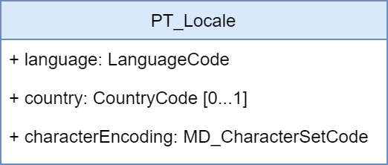

Figure 17-8 – ISO 19115-1:2014 PT_Locale class.

The PT_Locale class as defined in ISO 19115-1:2014 has the following members:

* LanguageCode – required ISO 639-2/T, 3-letter code in lowercase; that is, “fra”
* CountryCode – optional ISO 3166-1 2-letter code in uppercase; that is,“CA” intended to be used when the national language differences can impact the interpretation or processing of localized content
* MD_CharacterSetCode – required MD_CharacterSetCode

NOTE: Since codes for language, country, and character sets are defined as entries in a “codelists catalogue” that is included in the S-100 Schema distribution, the codelist values must be identical to keys in this file.

EXAMPLE: The codelist value  for LanguageCode is 'eng'. It is encoded in the XML attribute codeListValue.

<lan:LanguageCode  codeList="http://www.iho.int/S100/5.0.0/resources/Codelists/cat/codelists.xml#S100_MD_LanguageCode" codeListValue="eng">English</lan:LanguageCode>

For more details and examples, see the documentation and samples provided with the S-100 generic Schemas.

The implementation of the PT_Locale type provides the necessary structure to consistently define and communicate the key language characteristics within metadata or other geospatial resources.

Additionally, the localization framework provides the support for using multiple languages in the metadata records by extending CharacterString simple type with PT_FreeText and LocalisedCharacterString subtypes as illustrated in Figure 17-9 below.

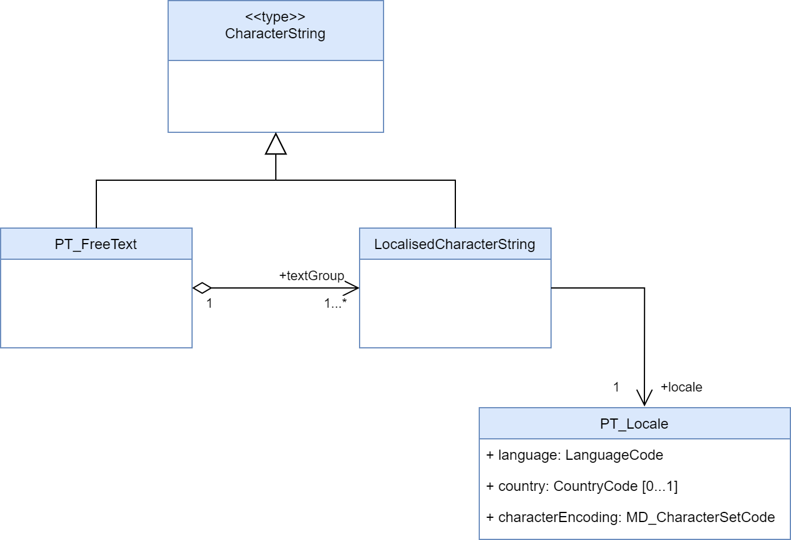

Figure 17-9 – ISO 19115-1:2014 PT_FreeText and LocalisedCharacterString subtypes

This allows any free text metadata record instances expressed in the default metadata language to also be expressed in other languages by aggregating the corresponding localized translations using LocalisedCharacterString and adding a reference to the underlying otherLocale definition. The diagram below shows a pseudo-XML implementation example illustrating how such aggregations should be constructed.

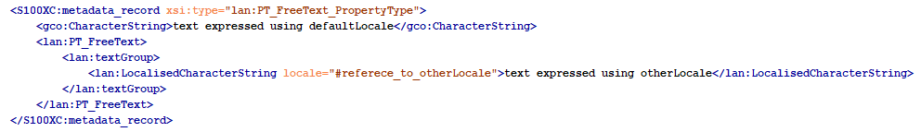

## Encoding of S-100 Exchange Set Catalogue elements in multiple languages

The S100 Exchange Set Catalogue model provides two elements: defaultLocale and otherLocale to define and indicate the languages used for all metadata records within an instance of an Exchange Catalogue. Only one defaultLocale is permitted within the core section of the S100 Exchange Set Catalogue (within S100_ExchangeCatalogue) and it is intended to communicate the default language used for all Catalogue records. Since the expected default language is English and the default character set is UTF-8 the defaultLocale element is optional and can be omitted. In most situations, however, it is prudent to explicitly define defaultLocale to prevent any confusion and more readily support data sharing with other user communities that might not be fully aware of S-100 conventions. This can be achieved as illustrated below.

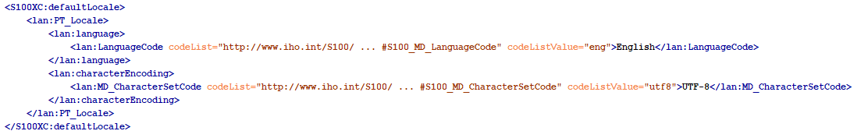

Data producing agencies wishing to provide additional localized translations of any of the Catalogue records can achieve so by first defining otherLocale and then referring to it when required. The first step can be achieved as illustrated below and, similarly to defaultLocale, this only needs to be defined once within the core section of the S100 Exchange Set Catalogue (within S100_ExchangeCatalogue) for each additional language used in a Catalogue instance. This approach is intended to communicate any additional language used for localized Catalogue records.

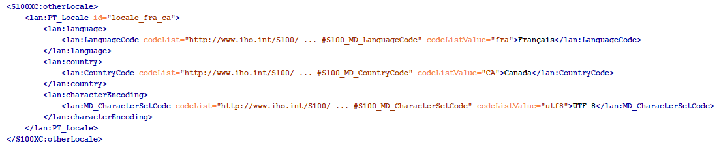

Of note is the id attribute of PT_Locale. When used in otherLocale definition, it needs to be a unique, ideally descriptive identification of a specific language which can be used as a reference by localized records. With the otherLocale element defined, any free text instances captured using the default language can also provide corresponding localized translations using PT_FreeText and LocalisedCharacterString subtypes as illustrated below.

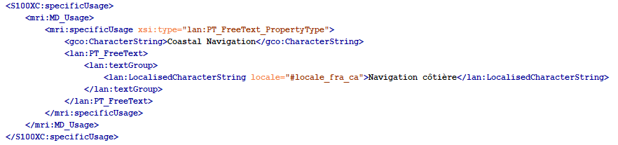

## Indicating languages used inside geospatial resources described in S-100 Exchange Set Catalogue

Data producing agencies using multiple languages in their products or other resources, who wish to explicitly indicate the languages used can use the same localization framework. In contrast to the metadata records, where language definitions are applicable to all records in an Exchange Catalogue instance, the default and other language definitions are individual resource specific. This is accomplished by defining default and/or other languages in the same way as before but placing them inside specific resource records. For example, a data producing agency wishing to communicate that a specific dataset includes features encoded using multiple languages can add the defaultLocale and otherLocale definitions inside the corresponding dataset discovery metadata record. At the resource level, both of these elements are optional and English UTF-8 encoding is considered to be the default therefore there is generally no need to capture this fact explicitly.

S-100 support file resources are a special case, as the textual information inside them is intended to be in a single language. As with all other resources, English UTF-8 encoding is the default therefore there is no need to capture this fact explicitly. It would be prudent, however, to define support file specific defaultLocale when the language used for the content is other than English. Both the S-100 Exchange Set Catalogue and S-100 Datasets can reference any number of support resources. The diagram below shows a pseudo-XML version with examples of MRN-based identifiers used as references between datasets and support resources. This illustrates the mechanism for using a predefined referencing system to interconnect the independently captured metadata records for datasets and support resources.

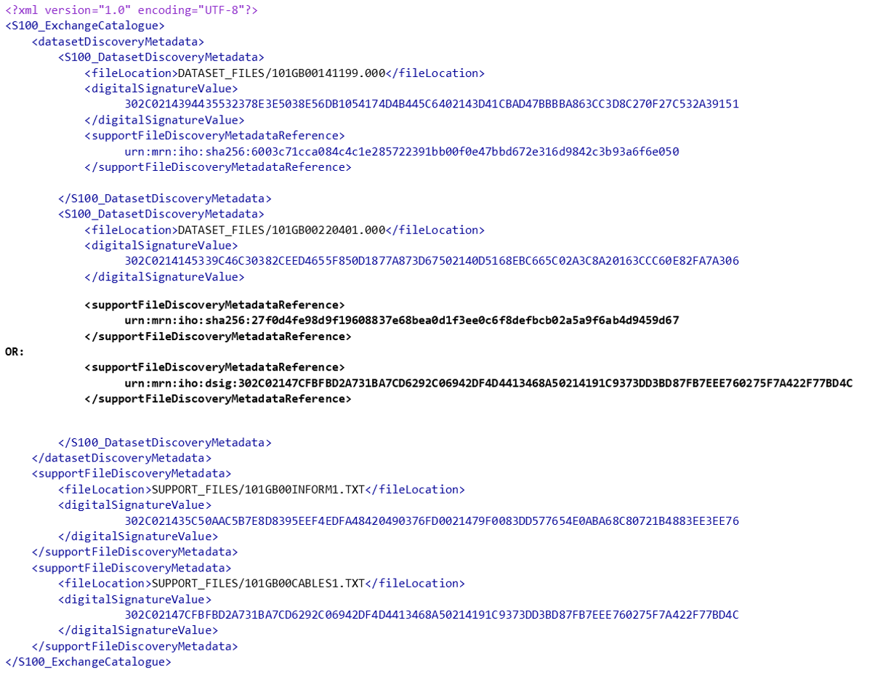

The above diagram also illustrates the optional defaultLocale fully omitted for any resources encoded using English UTF-8 thus simplifying the related metadata content. At the same time, data producers wishing to supply support resources in other languages can achieve this by capturing them independently and adding the corresponding metadata records, including defining their defaultLocale, as appropriate. The diagram below shows a pseudo-XML metadata example of a support resource supplied as two individual files one in English and the other in French.

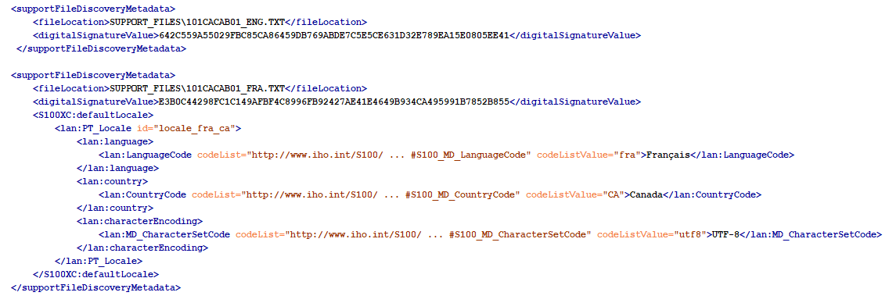

While the localization framework currently allows a high degree of flexibility, data producers are strongly encouraged to apply one consistent multilanguage support approach across their entire S-100 product portfolios to ensure a consistent user experience. The recommended approach is to provide all support resources in any other officially supported language in addition to English.

## Encoding of maintenance information

The interval described by *userDefinedMaintenanceFrequency* is with respect to the issue date and time of the dataset described by this dataset discovery metadata block. End-user’s and distributor’s systems should use this interval for planning any automated operations to obtain the successor dataset, but must allow for delays or variations in the actual availability of successor dataset(s).

The format for *userDefinedMaintenanceFrequency* is given by the XML built-in datatype *duration*, which can be validated by off-the-shelf XML parsers. See “*XML Schema Part 2: Datatypes (2nd edition) - Clause 3.2.6 duration*” (relevant extracts below):

The lexical representation for **duration** is the ISO 8601 extended format PnYnMnDTnHnMnS, where nY represents the number of years, nM the number of months, nD the number of days, ‘T’ is the date/time separator, nH the number of hours, nM the number of minutes and nS the number of seconds. The number of seconds can include decimal digits to arbitrary precision.

The values of the Year, Month, Day, Hour and Minutes components are not restricted but allow an arbitrary unsigned integer; that is, an integer that conforms to the pattern [0-9]+.. Similarly, the value of the Seconds component allows an arbitrary unsigned decimal. Following ISO 8601, at least one digit must follow the decimal point if it appears.

Reduced precision and truncated representations of this format are allowed provided they conform to the following:

* If the number of years, months, days, hours, minutes, or seconds in any expression equals zero, the number and its corresponding designator ·may· be omitted. However, at least one number and its designator ·must· be present.
* The seconds part ·may· have a decimal fraction.
* The designator ‘T’ must be absent if and only if all of the time items are absent. The designator ‘P’ must always be present.

### Encoding and interpretation rules in S-100 metadata

1. Restriction to non-negative durations: S-100 restricts the duration type by prohibiting zero or negative values of duration in userDefinedMaintenanceFrequency.
2. Number of digits: S-100 recommends (but does not require) using 2 digits for the months, days, hours, minutes, components, when they are present. If the seconds component is encoded, two digits are recommended for the number of whole seconds (for example, encode 0.5 seconds as PT00.5S; encode 100 seconds as PT01M40S).
3. Start and end instants: The start and end instants of the interval calculated by combining userDefinedMaintenanceFrequency with the issue date/time must be interpreted according to Part 3 Clause 3-8. The value must be encoded appropriately; this means that smaller date/time components must not be encoded unless the availability of the successor dataset is known to the corresponding level of precision. Smaller units should be used when the availability is known to the corresponding precision, such as “48 hours” instead of “2 days” when the successor dataset availability is planned to the hour.
4. Encoding of zero components: Zero components must be encoded if and only if they are significant for indicating the granularity of the start/end instants of the interval.
5. Variability: A variation of ±X should be allowed for, where X is the component of smallest granularity; if the value of the smallest component is 1, variability is unspecified.
6. Stability for successive datasets, and exceptions: The value of this attribute will normally be stable over a sequence of predecessor/successor datasets. The alternate encoding using maintenanceDate should be used for known exceptional circumstances affecting the release of a successor, such as an office closure at the end of the intervening period, reverting to normal encoding with userDefinedMaintenanceFrequency when the normal update schedule is restored.
7. Off-schedule updates: Communication of exceptional, unforeseeable off-schedule issues of data such as emergency hurricane forecasts should be provided for by other means than userDefinedMaintenanceFrequency or maintenanceDate attributes, since they are by definition unforeseeable.
8. Supersession: If both userDefinedMaintenanceFrequency and maintenanceDate are encoded in the same discovery metadata block, the maintenanceDate supersedes the userDefinedMaintenanceFrequency.

EXAMPLES:

Table 17-4 – Maintenance metadata (examples)

|  |  |  |  |  |
| --- | --- | --- | --- | --- |
| **No.** | **maintenanceAnd‌UpdateFrequency** | **maintenanceDate** | **userDefined‌Maintenance‌Frequency** | **Remarks** |
| 1 | -- | -- | P3DT10H30M | An interval of 3 days, 10 hours, and 30 minutes. Variability +/-1 minute. |
| 2 | -- | -- | PT6H | An interval of exactly 6 hours, with a variability of +/1 hour. |
| 3 | -- | -- | P30M | An interval of 30 months. |
| 4 | -- | -- | PT30M | An interval of 30 minutes. |
| 5 | -- | -- | P6H  P30S  P30M10S | Invalid (they contain time components but lack the ‘T’ designator) |
| 6 | -- | -- | PT30m | Invalid (‘m’ should be upper-case). |
| 7 | -- | -- | PT12:30  P3DT10H 30M | Invalid (the ‘:’ or space separators are not allowed, only the separators specified by the XML Schema datatypes specification for duration are allowed) |
| 8 | -- | -- | P1M | One month, variability unknown. According to the “Start and end instants” rule, will be interpreted as the same day in the following month, or the nearest preceding day if there is no such date in the following month.  If the issue date of the current dataset is 30 August, the successor dataset can be expected to be issued between midnight at the beginning of 30 September and midnight at the end of 30 September. |
| 9 | -- | -- | P1M00D | One month, with a variability of +/- 1 day. With a dataset issued on January 31 2021, the next dataset is expected on February 28, 2021; with a dataset issued on January 31, 2024 means the next dataset is expected February 29, 2024. A 1-day variation before after those dates should be anticipated. |
| 10 | -- | -- | P30D | 30 days, variability +/- 1 day. With a dataset issued on January 31, 2021 it means the next dataset is expected on March 2, 2021; with a dataset issued on January 31, 2024 it means the next dataset is expected on March 1, 2024. A 1-day variation should be allowed for in both cases. |
| 11 | irregular | cit:CI_Date >  cit:dateType=nextUpdate  cit:date=2021-10-25 | -- | On 25 October 2021, at an unspecified time on that date. |
| 12 | irregular | cit:CI_Date >  cit:dateType=nextUpdate  cit:date=2021-10-25T14:00:00Z | -- | On 25 October 2021, at 2 pm UTC. |
| 13 | asNeeded | cit:CI_Date >  cit:dateType=nextUpdate  cit:date=2021-10-25T14:00:00Z | -- | To encode an exception to a dataset sequence normally on a regular schedule. Next dataset will be available on 25 October 2021, at 2 pm UTC. |

XML encoding examples:

EXAMPLE 1: Dataset is updated at an interval of 6 hours:

<mri:resourceMaintenance>  
 <mmi:MD_MaintenanceInformation>  
 <mmi:userDefinedMaintenanceFrequency>  
 <gco:TM_PeriodDuration>PT06H</gco:TM_PeriodDuration>  
 </mmi:userDefinedMaintenanceFrequency>  
 </mmi:MD_MaintenanceInformation>  
</mri:resourceMaintenance>

EXAMPLE 2: Dataset is normally updated on a regular schedule, but the next update will be on 1 January 2022 at 5 am local time in the time zone with UTC offset -5 hours (for example, 5 am US Eastern Standard Time). The codeList attributes must be populated with the URL of the appropriate codelist, which will be in the ISO or S-100 Schema distribution package.

<mri:resourceMaintenance>  
 <mmi:MD_MaintenanceInformation>  
 <mmi:maintenanceAndUpdateFrequency>  
 <mmi:MD_MaintenanceFrequencyCode codeList="http://...." codeListValue="asNeeded">  
 empty, or any text in any single language

</mmi:MD_MaintenanceFrequencyCode>  
 </mmi:maintenanceAndUpdateFrequency>  
 <mmi:maintenanceDate>  
 <cit:CI_Date>  
 <cit:date>  
 <gco:DateTime>2022-01-01T05:00:00-05:00</gco:DateTime>  
 </cit:date>  
 <cit:dateType>  
 <cit:CI_DateTypeCode codeList="http://..." codeListValue="nextUpdate">

empty, or any text in any single language

</cit:CI_DateTypeCode>  
 </cit:dateType>  
 </cit:CI_Date>  
 </mmi:maintenanceDate>  
 </mmi:MD_MaintenanceInformation>  
</mri:resourceMaintenance>

EXAMPLE 3: Dataset has no consistent update schedule. The next update will be on 1 January 2022 at an unspecified time.

<mri:resourceMaintenance>

<mmi:MD_MaintenanceInformation>

<mmi:maintenanceAndUpdateFrequency>

<mmi:MD_MaintenanceFrequencyCode codeList="http://...." codeListValue="irregular"/>

</mmi:maintenanceAndUpdateFrequency>

<mmi:maintenanceDate>

<cit:CI_Date>

<cit:date>

<gco:Date>2022-01-01</gco:Date>

</cit:date>

<cit:dateType>

<cit:CI_DateTypeCode codeList="http://...." codeListValue="nextUpdate"/>

</cit:dateType>

</cit:CI_Date>

</mmi:maintenanceDate>

</mmi:MD_MaintenanceInformation>

</mri:resourceMaintenance>